Purpose: Day 12 Classwork and Assignment
Date: 07/01/2026
Author: Vinayak Majhi
ID: 58618
Batch ID: 25SUB4505 - DATACOM+5G

ClassWork

Q.1 Implement a generic DynArray class using templates that can store elements of any type.

Operations
Constructors

Default

Parameterized (size)

Parameterized (size, element)

Destructor

Display()

// Purpose: Generic Dynamic Array using Templates
// Date: 07/01/2026
// Author: Vinayak Majhi
// ID: 58618
// Batch ID: 25SUB4505 - DATACOM+5G

#include <iostream>

using namespace std;

template <class T>
class DynArray {
T *arr;
int size;

public:
DynArray() {
size = 0;
arr = nullptr;
}

DynArray(int s) {
size = s;
arr = new T[size];
}

DynArray(int s, T value) {
size = s;
arr = new T[size];
for (int i = 0; i < size; i++)
arr[i] = value;
}

void display() const {
for (int i = 0; i < size; i++)
cout << arr[i] << " ";
cout << endl;
}

~DynArray() {
delete[] arr;
}
};

int main() {
DynArray<int> a1(5, 10);
DynArray<float> a2(3, 2.5f);

a1.display();
a2.display();

return 0;
}

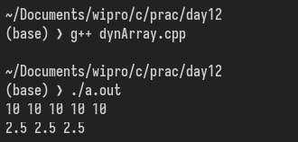

Q 2. Design a generic stack using class templates.

Operations
push

pop

top

isEmpty

// Purpose: Custom cat command with line numbers (-n option)
// Date: 05/01/2026
// Author: Vinayak Majhi
// ID: 58618
// Batch ID: 25SUB4505 - DATACOM+5G

// Purpose: Generic Stack using Templates
// Date: 07/01/2026
// Author: Vinayak Majhi
// ID: 58618
// Batch ID: 25SUB4505 - DATACOM+5G

#include <iostream>

using namespace std;

template <class T> class MyStack {
T *arr;
int topIndex;
int capacity;

public:
MyStack(int cap = 10) {
capacity = cap;
arr = new T[capacity];
topIndex = -1;
}

void push(T value) {
if (topIndex == capacity - 1) {
cout << "Stack Overflow\n";
return;
}
arr[++topIndex] = value;
}

void pop() {
if (isEmpty()) {
cout << "Stack Underflow\n";
return;
}
topIndex--;
}

T top() const {
if (isEmpty())
throw runtime_error("Stack is empty");
return arr[topIndex];
}

bool isEmpty() const { return topIndex == -1; }

~MyStack() { delete[] arr; }
};

int main() {
MyStack<int> s(5);
s.push(10);
s.push(20);

cout << "Top: " << s.top() << endl;
s.pop();
cout << "Top after pop: " << s.top() << endl;

return 0;
}

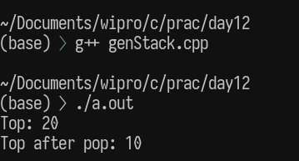

Q.3 Create a class template Matrix<T> that:

Stores a 2D matrix

Adds two matrices

Displays matrix

// Purpose: Matrix Operations using Class Templates
// Date: 07/01/2026
// Author: Vinayak Majhi
// ID: 58618
// Batch ID: 25SUB4505 - DATACOM+5G

#include <iostream>

using namespace std;

template <class T> class Matrix {
int rows, cols;
T mat[10][10];

public:
Matrix(int r, int c) : rows(r), cols(c) {}

void input() {
for (int i = 0; i < rows; i++)
for (int j = 0; j < cols; j++)
cin >> mat[i][j];
}

Matrix add(const Matrix &m) const {
Matrix result(rows, cols);
for (int i = 0; i < rows; i++)
for (int j = 0; j < cols; j++)
result.mat[i][j] = mat[i][j] + m.mat[i][j];
return result;
}

void display() const {
for (int i = 0; i < rows; i++) {
for (int j = 0; j < cols; j++)
cout << mat[i][j] << " ";
cout << endl;
}
}
};

int main() {
Matrix<int> m1(2, 2), m2(2, 2);
cout << "Enter Matrix 1:\n";
m1.input();
cout << "Enter Matrix 2:\n";
m2.input();

Matrix<int> m3 = m1.add(m2);
cout << "Result Matrix:\n";
m3.display();

return 0;
}

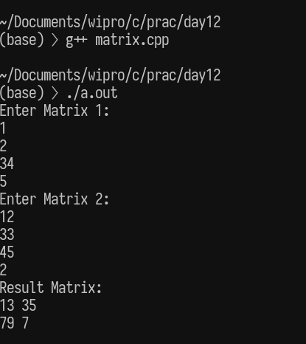

Q.4 Re-implement the dynamic array program using unique_ptr instead of raw pointers.

Tasks

Initialize values

Print elements

Ensure proper cleanup

// Purpose: Dynamic Array using unique_ptr
// Date: 07/01/2026
// Author: Vinayak Majhi
// ID: 58618
// Batch ID: 25SUB4505 - DATACOM+5G

#include <iostream>
#include <memory>

using namespace std;

unique_ptr<int[]> createArray(int size) {
if (size <= 0)
throw invalid_argument("Invalid size");

unique_ptr<int[]> arr(new int[size]);

for (int i = 0; i < size; i++)
arr[i] = (i + 1) * 10;

return arr;
}

int main() {
try {
int size;
cout << "Enter size: ";
cin >> size;

unique_ptr<int[]> arr = createArray(size);

cout << "Array elements: ";
for (int i = 0; i < size; i++)
cout << arr[i] << " ";
cout << endl;
} catch (exception &e) {
cout << "Exception: " << e.what() << endl;
}

return 0;
}

